Project Design Phase-II
Data Flow Diagram & User Stories

Date | 13 July 2026
Team ID | -
Project Name | Book Store
Maximum Marks | 4 Marks

Data Flow Diagrams:
Data Flow Diagram (DFD) is a graphical representation of how data moves through the Online Book Store system. It illustrates how users interact with the application, how information is processed, and how data is stored in the database. The DFD helps identify the flow of information between customers, administrators, the application, and the database, ensuring that the system requirements are clearly understood. It also provides a clear view of the processes involved in user registration, login, book search, shopping cart, order management, and payment processing.
Example:
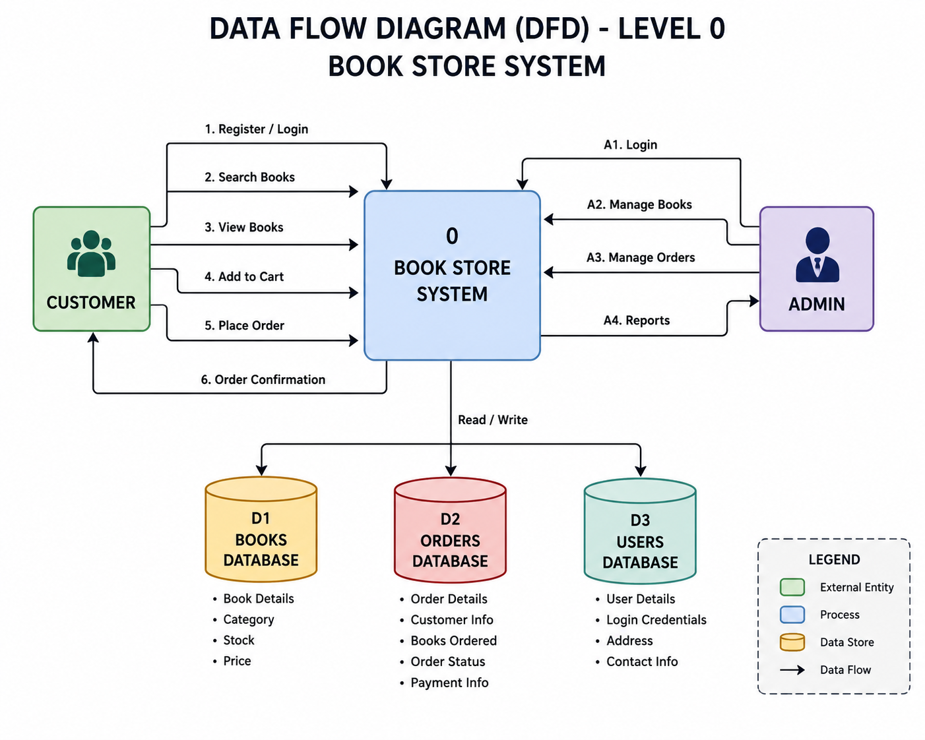
User Stories
Use the below template to list all the user stories for the product.
User Type | Functional Requirement (Epic) | User Story Number | User Story / Task | Acceptance criteria | Priority | Release
Customer (Web user) | Registration | USN-1 | As a user, I can register with my email and password. | User account is created successfully. | High | Sprint-1
Customer(Web User) | Login | USN-2 | As a user, I can log in using valid credentials | User is redirected to the dashboard. | High | Sprint-1
Customer(Web User) | Browse Books | USN-3 | As a user, I can view all available books | All books aare displayed | High | Sprint-1
Customer(Web User) | Search Books | USN-4 | As a user, I can search books by title,author,or category | Matching books are displayed. | High | Sprint-2
Customer(Web User) | Shopping Cart | USN-5 | As a user, I can add books to my shopping cart. | Selected books are added to the cart. | High | Sprint-2
Customer(Web User) | Place Order | USN-6 | As a user, I can place an order for selected books. | Order is placed successfully. | High | Sprint-3
Customer (Care Executive) | Customer Support | USN-7 | As a customer care executive, I can respond to customer queries and order issues. | Customer issues are resolved successfully. | Medium | Sprint-3
Administrator | Book Management | USN-8 | As an admin, I can add, edit, and delete books. | Book details are updated successfully. | High | Sprint-4
Administrator | Order Management | USN-9 | As an admin, I can manage customer orders. | Orders can be viewed and updated. | High | Sprint-4
Administrator | User Management | USN-10 | As an admin, I can manage user accounts. | User accounts can be viewed and managed. | Medium | Sprint-4

